Prescription for Dental & Surgical Loupe

Clinic: Bedford Medical Clinic |  | Name: David Parsons
Sex: M | Age: 62 | Height: 176cm
Address:

1. Magnification: 2.5x
2. Prescription Lens ( optometrist to complete if you want prescription lenses)
 | SPH | CYL | AXIS | ADD
-R
L

3. Working Distance: _______50_______cm ( between 35-55cm)
4. Pupil Distance: (needs to be accurate- An Optical Technician needs to complete- Get a PD at infinity( straight ahead) and focusing on something at nominated working distance.
 | Right (PDR) | Total (PD) | Left (PDL)
∞ | 33.5 | 66.5 | 33
WD cm
WD 40 cm

5. Frame color: Black (Spectacle 1)
6. Frontal Photograph / Side Photograph at your WD– attach the photos in JPEG file
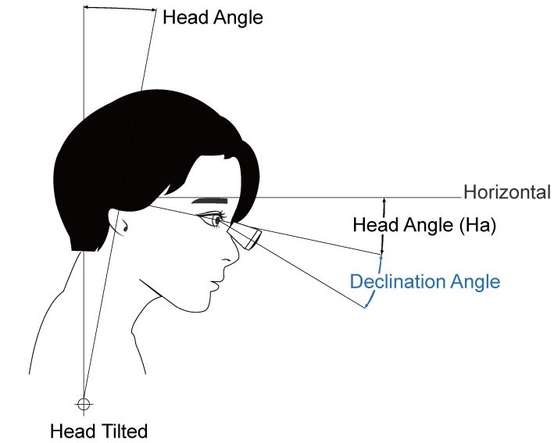
7. Declination Angle – personal request IF needed
8. Noted Items:
