Garment Measuring Guide
The following guide is intended as an aid to
help the user select the correct size garment .

The treatment type will determine the garment type e.g. hydroven® 1 for uniform compression, hydroven® 3 for graduated pressure or hydroven® 12 for specialist multi chamber therapy.
When determining the correct size garment:
- Remove any bandaging, stockings or bulky dressings
- Measure the points as shown on the diagram below
- DO NOT pull the measuring tape tight
- Make sure the garment extends beyond the area under treatment
Refer to the garment list at the end of this document.
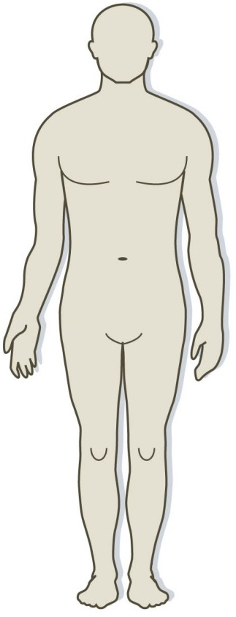

Half Leg Length
Full Leg Length
Hand Circumference
Half Arm Length
Thigh Circumference
Full Arm Length
Below Elbow Circumference
Below Knee Circumference

Arm Sizing
Upper Arm Circumference

Leg Sizing

Hydroven - 1 SINGLE Chamber Leg Garments
Order Code | Type | Length (L) | Thigh Circumference (W)
5101L50 | Half Leg | 50cm | 61cm
5101L66 | Full Leg | 66cm | 64cm
5101L71 | Full Leg | 71cm | 66cm
5101L76 | Full Leg | 76cm | 72cm
5101L84 | Full Leg | 84cm | 72cm
5101L92 | Full Leg | 92cm | 72cm

Hydroven - 3 THREE Chamber Leg Garments
Order Code | Type | Length (L) | Thigh Circumference (W)
5103L50 | Half Leg | 50cm | 61cm
5103L66 | Full Leg | 66cm | 64cm
5103L71 | Full Leg | 71cm | 66cm
5103L76 | Full Leg | 76cm | 72cm
5103L84 | Full Leg | 84cm | 72cm
5103L92 | Full Leg | 92cm | 72cm

Hydroven - 1 SINGLE Chamber ARM Garments
Order Code | Type | Length (L) | Circumference Hand (H) | Circumference Shoulder (S)
5101A51 | Half Arm | 51cm | 44cm | 56cm
5101A68 | Full Arm | 68cm | 44cm | 62cm
5101A78 | Full Arm | 78cm | 44cm | 62cm

Hydroven - 3 THREE Chamber ARM Garments
Order Code | Type | Length (L) | Circumference Hand (H) | Circumference Upper Arm (S)
5103A68 | Full Arm | 68cm | 44cm | 62cm
5103A78 | Full Arm | 78cm | 44cm | 62cm

Hydroven - INSERTS
(Compatible with Hydroven 1 and Hydroven 3 garments)
Order Code | Type | Length (L) | Added Circumference Wide End | Added Circumference Narrow End
510LI50 | Half Leg Insert | 50cm | 19cm | 14cm
510LI66 | Full Leg Insert | 66cm | 19cm | 14cm
510LI71 | Full Leg Insert | 71cm | 19cm | 14cm
510LI76 | Full Leg Insert | 76cm | 19cm | 14cm
510LI84 | Full Leg Insert | 84cm | 19cm | 14cm
510LI92 | Full Leg Insert | 92cm | 19cm | 14cm
510AI68 | Full Arm Insert | 68cm | 17cm | 12cm
510AI78 | Full Arm Insert | 78cm | 17cm | 12cm

Hydroven 12 - TWELVE Channel Arm Garments
Order Code | Type | Length (L) | Circumference Upper Arm (S)
316A68 | Full Arm | 68cm | 62cm
316A78 | Full Arm | 78cm | 62cm
Hydroven - 12 TWELVE Channel Arm Inserts
Order Code | Type | Length (L) | Additional Width at Upper Arm
316AI68 | Full Arm | 68cm | 17cm
316AI78 | Full Arm | 78cm | 17cm

Hydroven 12 - TWELVE Channel Leg Garments
Order Code | Type | Length (L) | Thigh Circumference
316L76S | Standard Leg | 76cm | 71cm
316L84S | Standard Leg | 84cm | 71cm
316L76W | Wide Leg | 76cm | 79cm
316L84W | Wide Leg | 84cm | 79cm
Hydroven - 12 TWELVE Channel Leg Inserts
Order Code | Type | Length (L) | Additional Width at Thigh
316LI76 | Leg Insert | 76cm | 19cm
316LI84 | Leg Insert | 84cm | 19cm

